Title of Mass Email:
Prepare for a Career in AI & Data Science with the SHC Career Series

Content of Mass Email:

Message from Shun Hing College

Dear residents of Jockey Club Student Village III,
We announce with great pleasure that Shun Hing College will be hosting its first XXXXXXXXXXXX…

Requirement:
- Always copy the "plain text" into this template rather than copying an existing email or moving elements from this template to your file. This can avoid 99% of the problems.
- Do not use Google Doc to share and edit. It changes format.
- Font: Arial, Size 12. DO NOT use other Serif fonts such as Times New Roman.
- DO NOT use the college logo with HKU for the signature of your own team without approval. Do not put “Tutorial Team” at the end of the email if your event is not organized by the Tutorial Team.
- Do not put “SHC” or “Shun Hing College” before your team’s name.
- You can add your team’s own social media links in the email, but put them in the content. Do not change the ending signature in this template.
- Double-check that if your links or QR code work.
- View in MS Word using the Web Layout to ensure everything displays correctly.
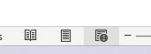

- DO NOT re-size the college logo in the signature.
Reference Image:

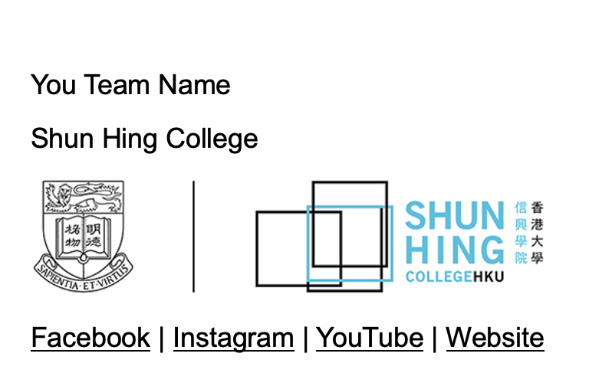

- When inserting images into mass emails, ensure the long edge of the image has a resolution of less than 1000 DPI. Shrink the image in Word to a comfortable size.
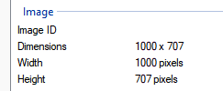

- If any poster needs to be printed, please attach a PDF with a resolution of 300 DPI in the correct size (A3/A4) along with this document to ensure quality.
- Check the grammar to avoid spelling issues.

You Team Name
Shun Hing College

Facebook | Instagram | YouTube | Website

